Progression in Calculation
June 2018

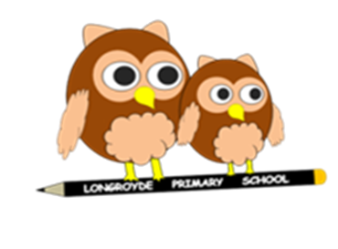

This document outlines the Progression in Calculations for KS1 and KS2 at Longroyde Primary School.

- The ‘Written Methods’ section contains the National Curriculum objective(s) and the end of year expectations and an example of this is provided.
- The ‘Developing Conceptual Understanding’ section illustrates how to build children’s understanding of the formal methods using a range of specific practical equipment and representations. The expected language for the formal methods is modelled in this section in the older year groups – this language should be used throughout whenever the formal method is used.
- The ‘Foundations’ section for each year group highlights the skills and knowledge that should be addressed on a regular basis within this year group to ensure that children have the requisite fluency to address the new approaches required.

 | Year 1 | Year 2 | Year 3 | Year 4 | Year 5 | Year 6
Written Methods | Read, write and interpret mathematical statements involving addition (+), subtraction (–) and equals (=) signs | Add and subtract two two-digit numbers using concrete objects, pictorial representations progressing to formal written methods  4 6  + 2 7  7 3  ¹ | Add and subtract numbers with up to three digits, using formal written methods of columnar addition and subtraction  4 2 3  + 8 8  5 1 1  ¹ ¹ | Add and subtract numbers with up to 4 digits using the formal written methods of columnar addition where appropriate  2 4 5 8  + 5 9 6  3 0 5 4  ¹ ¹ ¹ | 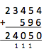  Add and subtract whole numbers with more than 4 digits, including using formal written methods (columnar addition and subtraction) | Solve addition and subtraction multi-step problems in contexts, deciding which operations and methods to use and why
Developing conceptual understanding | Number bonds  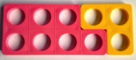  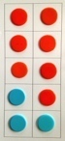  (Ten frame) Numicon  Use bonds of 10 to calculate bonds of 20  Count all  Count on  8  Count on, on number track, in 1s  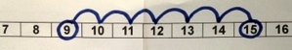  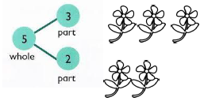  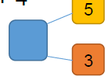  Part-whole  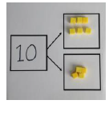 | Number track / Number line – jumps of 1 then efficient jumps using number bonds  18 + 5 = 23  46 + 27 = 73 Count in tens then bridge.  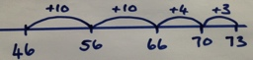  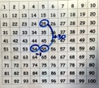  25 + 29 by + 30 then -1  (Round and adjust)  Partition and recombine  46 + 27 = 60 + 13 = 73  24 +10  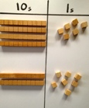  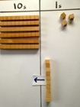  +10  +10 = 54  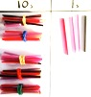  Regrouping to make ten  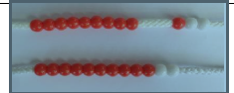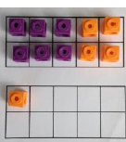 | Number line: 264 + 158 efficient jumps  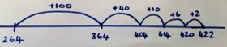  40 + 80 = 120 using 4 + 8 = 12  So 400 + 800 = 1200  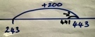  243 + 198  by +200 then -2  (Round and adjust)  Pairs that make 100  23 + 77  Base ten/Place value counters, 100s, 10s, 1s  24+15  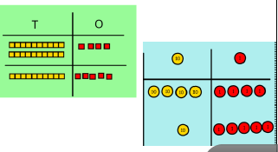  264 + 158 (Regrouping)  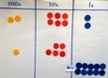  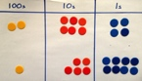  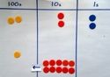  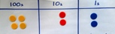  = 422  (Also with £, 10p and 1p) | Place Value Counters 2458 + 596  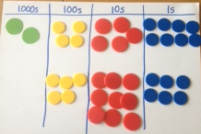  Show 2458 and 596  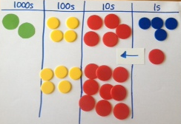  Combine the 1s.  Exchange ten 1s  for a 10 counter.  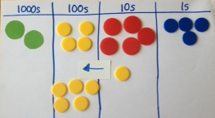  Combine the 10s.  Exchange ten 10s  for a 100 counter.  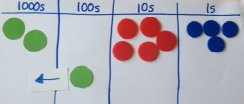  Combine the 100s.  Exchange ten 100s  for a 1000 counter  Read final answer  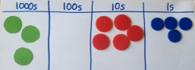  Three thousand and  fifty-four. | 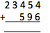  Set out the calculation  In columns.  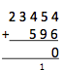  Find the sum of the ones.  4 ones + 6 ones = 10 ones  (or 1 ten and 0 ones)  so record 0 in the ones and  1 below the line in the tens.  Find the sum of the tens.  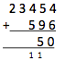  5 tens + 9 tens + 1 ten  = 15 tens (or 1 hundred  and 5 tens) so record a  5 in the tens and 1 below  the line in the hundreds.  Find the sum of the hundreds.  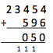  4 hundreds + 5 hundreds  + 1 hundred = 10 hundreds  (or 1 thousand and  0 hundreds) so record a  0 in the hundreds and a  1 in the thousands.  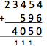  Find the sum of the thousands.  3 thousands + 1 thousand  = 4 thousands so record a  4 in the thousands column.  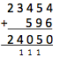  Find the sum of the ten thousands.  There are only 2 ten thousands  so record a 2 in the final column
Just know it! | Represent & use number bonds and related subtraction facts within 20  Add and subtract one-digit and two-digit numbers to 20, including zero | Recall and use addition and subtraction facts to 20 fluently, and derive and use related facts up to 100
Addition
Foundations | 1 more | 10 more  Number bonds: 20, 12, 13 | Add multiples of 10, 100 | Add multiples of 10s , 100s, 1000s | Add multiples of 10s , 100s, 1000s, tenths, | Add multiples of 10s , 100s, 1000s, tenths, hundredths
 | Number bonds: 5, 6 | Number bonds: 14,15  Add 1 digit to 2 digit by bridging. | Add single digit bridging through boundaries | Fluency of 2 digit + 2 digit | Fluency of 2 digit + 2 digit including with decimals | Fluency of 2 digit + 2 digit including with decimals
 | Largest number first.  Number bonds: 7, 8 | Partition second number, add tens then ones | Partition second number to add  Pairs of 100 | Partition second number to add  Decimal pairs of 10 and 1 | Partition second number to add | Partition second number to add
 | Add 10.  Number bonds: 9, 10 | Add 10 and multiples.  Number bonds: 16 and 17 | Use near doubles to add | Use near doubles to add | Use number facts, bridging and place value | Use number facts, bridging and place value
 | Ten plus ones.  Doubles up to 10 | Doubles up to 20 and multiples of 5  Add near multiples of 10. | Add near multiples of 10 and 100 by rounding and adjusting | Adjust both numbers before adding  Add near multiples | Adjust numbers to add | Adjust numbers to add
 | Use number bonds of 10 to derive bonds of 11 | Number bonds: 18, 19  Partition and recombine | Partition and recombine | Partition and recombine | Partition and recombine | Partition and recombine

Subtraction
 | Year 1 | Year 2 | Year 3 | Year 4 | Year 5 | Year 6
Written Methods | Read, write and interpret mathematical statements involving addition (+), subtraction (–) and equals (=) signs | Add and subtract two two-digit numbers using concrete objects, pictorial representations progressing to formal written methods ₆ ₁  7 3  - 4 6  2 7 | Add and subtract numbers with up to three digits, using formal written methods of columnar addition and subtraction ₂ ₃ ₁  3 4 4  - 1 8 7  1 5 7 | Add and subtract numbers with up to 4 digits using the formal written methods of columnar addition where appropriate  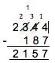 | Add and subtract whole numbers with more than 4 digits, including using formal written methods (columnar addition and subtraction) | Solve addition and subtraction multi-step problems in contexts, deciding which operations and methods to use and why
Developing conceptual understanding | Number bonds  (Ten frame) Difference between  7 and 10  6 less than 10 is 4  Count out, then count how many are left.  7 – 4 = 3  Count back on a number track, then number line.  15 – 6 = 9  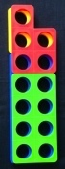  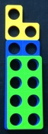  Difference between  13 and 8  13 – 8 = _  8 + _ = 13  Part-part/whole  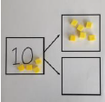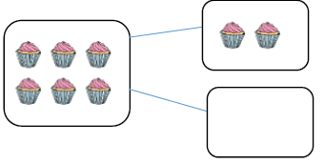 | Number track / Number line – jumps of 1 then efficient jumps using number bonds  23 – 5 = 18  Using a number line, 73 – 46 = 26  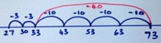  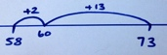  Difference between 73 – 58 by counting up, 58 + _ = 73  No exchange 36-14  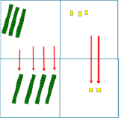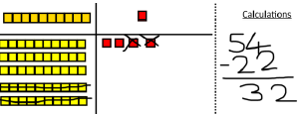  Exchanging, 73 – 46  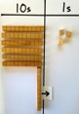  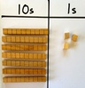  ‘Where’s the Exchange to  ‘forty and six?’ create ‘sixty thirteen’  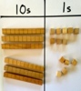  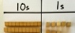  ‘Twenty seven’  ‘Now take away  the forty and six’ | Taking away and exchanging, 344 – 187  Place value counters  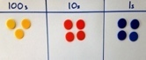  ‘Where’s the one  hundred and  eighty and  seven?  Exchange to create  three hundred and  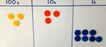  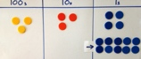  thirty and fourteen.  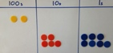  Now take away the  ‘seven’  Exchange to create two hundred, thirteen tens and seven  Now take away  the ‘eighty’  Now take away  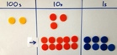  the ‘one hundred’ | Taking away and exchanging, 2344 – 187  Place value counters  Where’s the one hundred and eighty- seven?  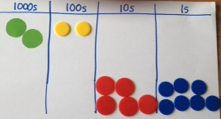  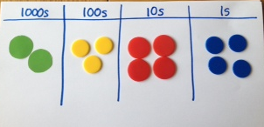  Exchange a 10 for ten 1s to create two thousand, three hundred and thirty and fourteen.  Now take away ‘seven’.  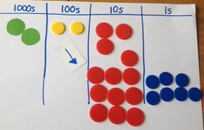  Exchange a 100 for ten 10s to create two thousand, two hundred, thirteen tens and seven.  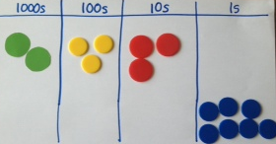  Now take away ‘eighty’  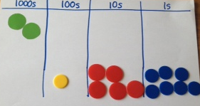  Now take away ‘one hundred’  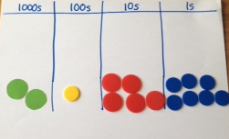  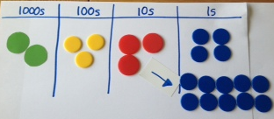  There are no thousands to take away. | Set out the calculation in columns  The 1s column: four subtract seven  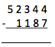  Because seven is greater  than four, exchange a 10 for  ten 1s. So there are now  three 10s and fourteen 1s.  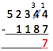  Fourteen 1s subtract seven 1s  makes seven 1s – record this.  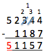  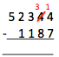  The 10s column: three subtract eight. Because eight is greater  than three, exchange a 100 for  ten 10s. So there are now two  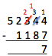  100s and thirteen 10s.  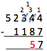  Thirteen 10s subtract eight 10s  makes five 10s – record this.  The 100s column: two subtract one. Two 100s subtract one 100  makes one 100 – record this.  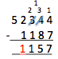  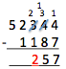  The 1000s column: two subtract one. Two 1000s subtract one 1000 makes one 1000 – record this.  The 10,000s column: there are only five 10000s with nothing to subtract. So record 5.  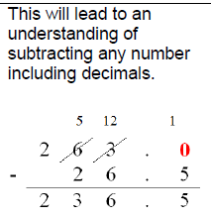
Just know it! | Represent and use number bonds and related subtraction facts within 20  Add and subtract one-digit and two-digit numbers to 20, including zero | Recall and use addition and subtraction facts to 20 fluently, and derive and use related facts up to 100
Foundations | 1 less | 10 less  Number bonds, subtraction: 20, 12, 13 | Subtract multiples of 10 and 100 | Subtract multiples of 10s , 100s, 1000s | Subtract multiples of 10s , 100s, 1000s, tenths, | Subtract multiples of 10s , 100s, 1000s, tenths, hundredths
 | Number bonds, subtraction: 5, 6 | Number bonds, subtraction: 14, 15 Subtract 1 digit from 2 digit by bridging | Subtract single digit by bridging through boundaries | Fluency of 2 digit subtract 2 digit | Fluency of 2 digit - 2 digit including with decimals | Fluency of 2 digit - 2 digit including with decimals
 | Count back  Number bonds, subtraction: 7, 8 | Partition second number, count back in 10s then 1s | Partition second number to subtract | Partition second number to subtract  Decimal subtraction from 10 or 1 | Partition second number to subtract | Partition second number to subtract
 | Subtract 10.  Number bonds, subtraction: 9, 10 | Subtract 10 and multiples of 10  Number bonds, subtraction: 16, 17 | Difference between | Difference between | Difference between | Use number facts bridging and place value
 | Teens subtract 10. | Subtract near multiples of 10 | Subtract near multiples of 10 and 100 by rounding and adjusting | Subtract near multiples by rounding and adjusting | Adjust numbers to subtract | Adjust numbers to subtract
 | Difference between | Difference between  Number bonds, subtraction: 18, 19 | Difference between | Difference between | Difference between | Difference between

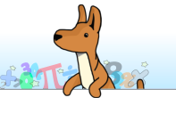
Multiplication
 | Year 1 | Year 2 | Year 3 | Year 4 |  | Year 5 |  | Year 6
Written Methods |  | Calculate mathematical statements for multiplication and division within the multiplication tables and write them using the multiplication (×), division (÷) and equals (=) signs | Write and calculate mathematical statements for ÷ using the x tables they know progressing to formal written methods. | Multiply two-digit and three-digit numbers by a one-digit number using formal written layout | 243  x 6  2058  1 | Multiply numbers up to 4 digits by a one- or two-digit number using a formal written method, including long multiplication for two-digit numbers | 243  x 36  7290  1458  8748  1 | Multiply multi-digit numbers up to 4 digits by a two-digit whole number using the formal written method of long multiplication  5172  x 38  155160  41376  196536  1  To multiply 5172 by 38 find the sum of 5172 x 30 & 5172 x 8.  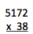  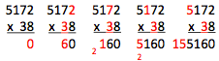  5172 x 30: This is the same as 5172 x 3 x 10. Therefore, record a 0 in the 1s column to take care of the ‘ten times bigger’ and begin to calculate 5182 x 3.  Then calculate 5172 multiplied by 8 and record beneath:  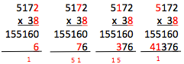  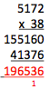  Finally add the  two parts together:
Developing conceptual understanding | 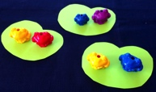  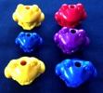  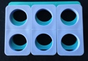  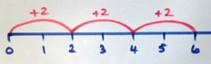  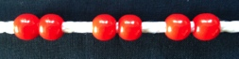  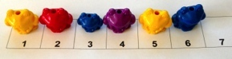  2 frogs on each lily pad. | 5 frogs on each lily pad  5 x 3 = 15  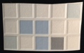  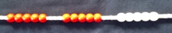  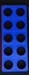  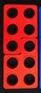  5 x 2 = 2 x 5  Build tables on counting stick  Link to repeated addition | If I know 10 x 8 = 80 then …  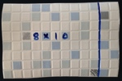  So 13 x 4 = 10 x 4 + 3 x 4  12  40  Build tables on counting stick  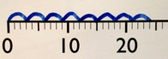  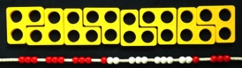  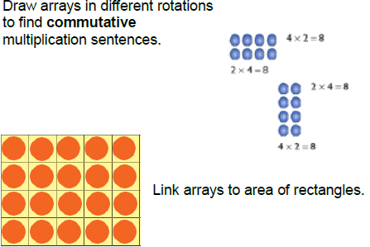  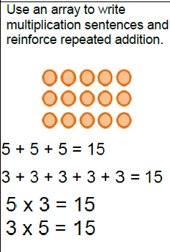 | 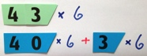  43 x 6 by partitioning  18  240  6  3  40  X  If I know 4 x 6 = 24 the 40 x 60 is ten times bigger.  40 x 6 = 240  3 x 6 = 18  43 x 6 = 258  13 x 16 by partitioning  10 3  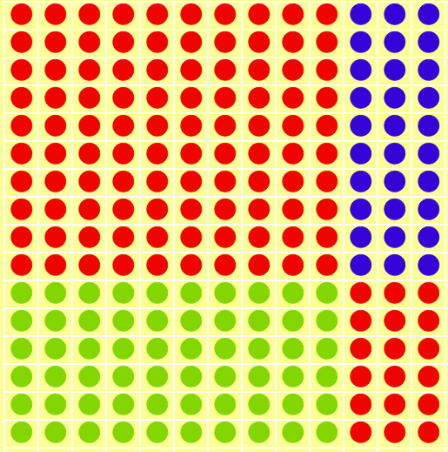  10  6  100 + 30 + 60 + 18 = 208  Build tables on counting stick |  | Grid method linked to formal written method  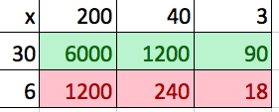  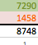  If I know 4 x 6 then 0.4 x 6 is ten times smaller  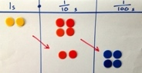  0.4 x 0.6 is ten times smaller again.
Just know it! | Count in multiples of twos, fives and tens | Recall and use x and ÷ facts for the 2, 5 and 10 x tables, including recognising odd and even numbers. | Recall and use x and ÷ facts for the 3, 4 and 8 times tables. | Recall x and ÷ facts for x tables up to 12 x 12. |  | Recall prime numbers up to 19  know and use the vocabulary of prime numbers, prime factors and composite (non-prime) numbers  Recognise and use square numbers and cube numbers, and the notation for squared (²) and cubed (³)
Foundations | Count in 2s | 2 x table | Review 2x, 5x and 10x | 4x, 8x tables  10 times bigger |  | 4x, 8x tables  100, 1000 times bigger |  | Multiplication facts up to 12 x 12
 | Count in 10s | 10 x table | 4x table | 3x, 6x and 12x tables |  | 3x, 6x and 12x tables  10, 100, 1000 times smaller |  | Partition to multiply mentally
 | Doubles up to 10 | Doubles up to 20 and multiples of 5 | Double two digit numbers | Double larger numbers and decimals |  | Double larger numbers and decimals |  | Double larger numbers and decimals
 | Count in 5s | 5 x table | 8 x table | 3x, 9x tables |  | 3x, 9x tables |  | Multiplication facts up to 12 x 12
 | Double multiples of 10 | Count in 3s | 3 x table | 11x, 7 x tables |  | 11x , 7 x tables  Partition to multiply mentally |  | Partition to multiply mentally
 | Count in 2s, 5s and 10s | 2 x, 5 x and 10 x tables | 6 x table or review others | 6x, 12 x tables |  | 6x, 12 x tables |  | Double larger numbers and decimals

Division
 | Year 1 | Year 2 | Year 3 | Year 4 | Year 5 |  | Year 6
Written Methods |  | Calculate mathematical statements for multiplication and division within the multiplication tables and write them using the multiplication (×), division (÷) and equals (=) signs | Write and calculate mathematical statements for ÷ using the x tables they know progressing to formal written methods. |  | Divide numbers up to 4 digits by a one-digit number using the formal written method of short division and interpret remainders appropriately for the context | 194 ÷ 6  3 2  6 1 9 ¹2  192 ÷ 6  = 32 | Divide numbers up to 4-digits by a two-digit whole number using the formal written method of long division and interpret remainders where appropriate for the context  Known multiplication facts:  13, 26, 39, 52, 65, …  10 x 13 = 130, 20 x 13 = 260 …  564 ÷ 13  4 3 r 5  13 5 6 ⁴4  564 ÷ 13 = 43 r 5 = 43 $\frac{5}{13}$  Divide numbers up to 4 digits by a two-digit whole number using the formal written method of long division, and interpret remainders as whole number remainders, fractions, or by rounding, as appropriate for the context  564 ÷ 13 4 3 . 3 8 …  13 5 6 4 . 0 0 …  5 2  4 4  - 3 9  5 0  - 3 9  1 1 0  - 1 0 4  6  = 43 r 5 = 43 $\frac{5}{13}$ = 43.4 (to 1dp)  Long Division  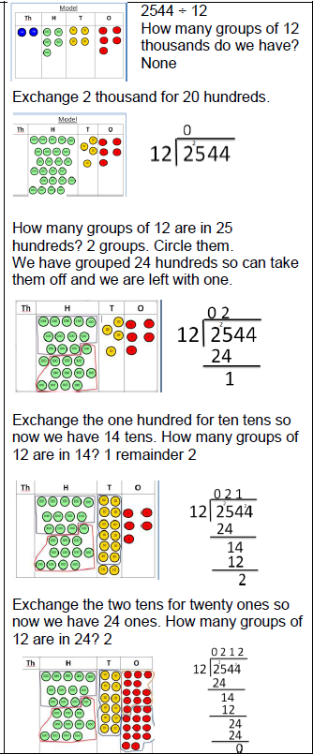
Developing conceptual understanding | 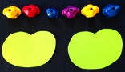  6 ÷2 = 3 by sharing into 2 groups and by grabbing groups of 2  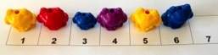  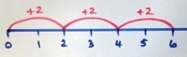  How many 2s? | 15 ÷ 3 = 5 in each group (sharing)  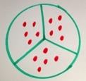  Link to fractions  15 ÷ 3 = 5 groups of 3 (grouping)  10 ÷2 = 5  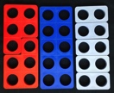  Use language of division linked to tables  How many 2s?  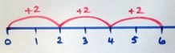 | 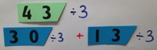  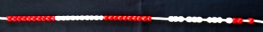  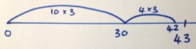  Grouping using partitioning  43 ÷ 3 If I know 10 x 3 …  Use language of division linked to tables  How many 3s?  Division within arrays  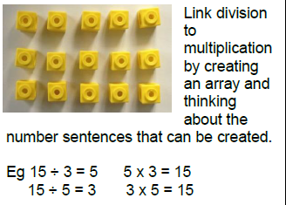  Short Division  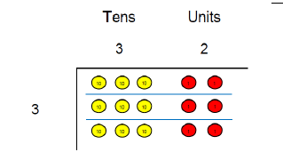 | Grouping using partitioning  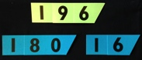  196 ÷ 6 If I know 3 x 6 … then 30 x 6…  ‘Chunking up’ on a number line  196 ÷ 6 = 32 r 4  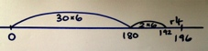  Use language of division linked to tables. | 192 ÷ 6 using place value counters to support written method  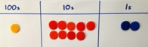  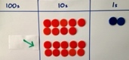  Exchange one  100 for ten 10s  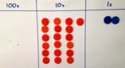  19 tens into  groups of 6  3 groups so that is 30 x 6,  exchange remaining 10 for ten 1s  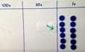  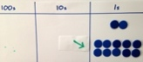  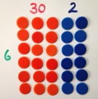  So 192 ÷ 6 = 32
Just know it! | Count in multiples of twos, fives and tens | Recall and use x and ÷ facts for the 2, 5 and 10 x tables, including recognising odd and even numbers. | Recall and use x and ÷ facts for the 3, 4 and 8 times tables | Recall x and ÷ facts for x tables up to 12 x 12. | Recall prime numbers up to 19  know and use the vocabulary of prime numbers, prime factors and composite (non-prime) numbers
Year | 1 | 2 | 3 | 4 | 5 |  | 6
Foundations | Count back in 2s | Division facts (2 x table) | Review division facts (2x, 5x, 10x table) | Division facts (4x, 8x tables)  10 times smaller | Division facts (4x, 8x tables)  100, 1000 times smaller |  | Division facts (up to 12 x 12)
 | Count back in 10s | Division facts (10 x table) | Division facts (4 x table) | Division facts (3x, 6 x, 12x tables) | Division facts (3x, 6 x, 12x tables)  Partition to divide mentally |  | Partition to divide mentally
 | Halves up to 10 | Halves up to 20 | Halve two digit numbers | Halve larger numbers and decimals | Halve larger numbers and decimals |  | Halve larger numbers and decimals
 | Count back in 5s | Division facts (5 x table) | Division facts (8 x table) | Division facts (3x, 9x tables) | Division facts (3x, 9x tables)  100, 1000 times smaller |  | Division facts (up to 12 x 12)
 | Halve multiples of 10 | Count back in 3s | Division facts (3 x table) | Division facts (11x, 7x tables) | Review division facts (11x, 7x tables)  Partition decimals to divide mentally |  | Partition to divide mentally
 | How many 2s? 5s? 10s? | Review division facts (2x, 5x, 10x table) | Division facts (6 x table) or review others | Division facts (6x, 12x tables) | Review division facts (6x, 12x tables) Halve larger numbers and decimals |  | Halve larger numbers and decimals

