

**Headteacher**

**R. J. Fox**

**BA (Hons) PGCE**

**NPQH**

Longroyde Primary School

A Foundation School

Field Top Road Longroyde Road

Rastrick, Brighouse Rastrick, Brighouse

West Yorkshire HD6 3XB West Yorkshire HD6 3AS

Key Stage 1, Early Years & Pre-School Key Stage 2

Tel (01484) 715300 Fax (01484) 401810

Email: admin@longroyde.calderdale.sch.uk www.longroyde.weebly.com

**Please address all correspondence to Longroyde Road**

**_______________________________________________________________________________**



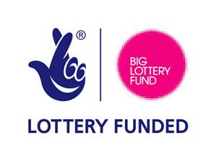

Working

together   
reaching for

individual goals

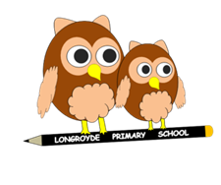

12th September 2019

Dear Parents/Carers

**Yorkshire Wildlife Park – October 2019**

We are taking Year 1 children to Yorkshire Wildlife Park on Tuesday, 22nd October to support our terms topic of “Dinosaurs and Animals, Furs, Feathers and Scales” and a contribution of **£18.00 per child** is requested. The cost of the trip is itemised below:



This will be a fantastic experience for the children and will enhance the topic and engage the children in their learning.

The staff and children will be travelling by coach. Children need to arrive promptly at school for 9.00 am as we will be departing at 9.15 am. **We are due to arrive back at school at approximately 4.00 pm.**

Further details regarding dress and lunch arrangements will be sent nearer the time.

No child will be omitted from the trip; however, if we do not receive sufficient payments the trip will be unable to go ahead.

We look forward to this exciting time!



**Mrs Buchanan & Miss Schofield**



**Yorkshire Wildlife Park – Tuesday, 22nd October 2019**

Please complete and return the form below by Friday, 11th October 2019.



|  |  |
| --- | --- |
| Name of Child: | Class: |
| Name of Parent: | Signature of Parent: |
| □ My child will be attending the trip and I enclose **£** | |