

**Headteacher**

**R. J. Fox**

**BA (Hons) PGCE**

**NPQH**

Longroyde Primary School

A Foundation School

Field Top Road Longroyde Road

Rastrick, Brighouse Rastrick, Brighouse

West Yorkshire HD6 3XB West Yorkshire HD6 3AS

Key Stage 1, Early Years & Pre-School Key Stage 2

Tel (01484) 715300 Fax (01484) 401810

Email: admin@longroyde.calderdale.sch.uk www.longroyde.weebly.com

**Please address all correspondence to Longroyde Road**

**_______________________________________________________________________________**



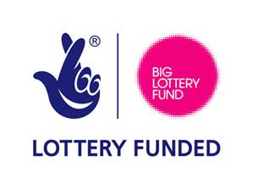

Working

together   
reaching for

individual goals

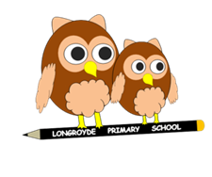

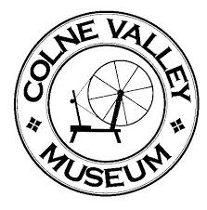21st October 2019

Dear Parents/Carers

**Year 2 Trip to Colne Valley Museum**

We are taking Year 2 children to Colne Valley Museum on Tuesday 19th November to support our term’s topic of Victorians and a contribution of **£11.50 per child** is requested. The cost of the trip is itemised below:

|  |  |
| --- | --- |
| Coach | £275.00 |
| Entry into museum | £196.50 |
| Total cost of trip | £471.50 |

This will be a fantastic opportunity for the children to learn about living in Victorian times, as they find themselves immersed in the daily life of the Pearson family and their friends and neighbours.  Children will be preparing their own lunch as part of the day, find out about spinning and weaving and try their hands at suitable crafts, including corn dollies.

The staff and children will be travelling by coach. Children need to arrive promptly at school for 8.30 am as we will be departing at 8.50 am. **We hope to arrive back at school for 3.00 pm but will keep you updated by text.**

Children are required to dress up as a Victorian child for the day – more information to follow.

No child will be omitted from the trip; however, if we do not receive sufficient payments the trip will be unable to go ahead.

We look forward to this exciting time!



**Mrs Geddes and Mrs Rashid**



**Colne Valley Museum – Tuesday 19th November 2019**

Please complete and return the form below by Friday, 15th November 2019.

|  |  |
| --- | --- |
| Name of Child: | Class: |
| Name of Parent: | Signature of Parent: |
| □ My child will be attending the trip and I enclose **£** | |

