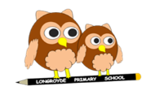

Longroyde Primary School

Policy for Handwriting

**Aims**

To know the importance of clear and neat presentation in order to communicate meaning effectively

1. To write legibly in both joined and printed styles with increasing fluency and speed by:

* Having a correct pencil grip
* Knowing that all letters start from the top, except d and e which start in the middle
* Forming all letters correctly
* Knowing the size and orientation of letters

**Model Used**

Longroyde Primary uses the Nelson Thornes Handwriting Scheme. It provides a clear, practical framework for implementing and developing a whole school handwriting policy. In this, pupils are actively encouraged to explore different styles of handwriting and develop their own style.

The scheme uses the following letter formation.

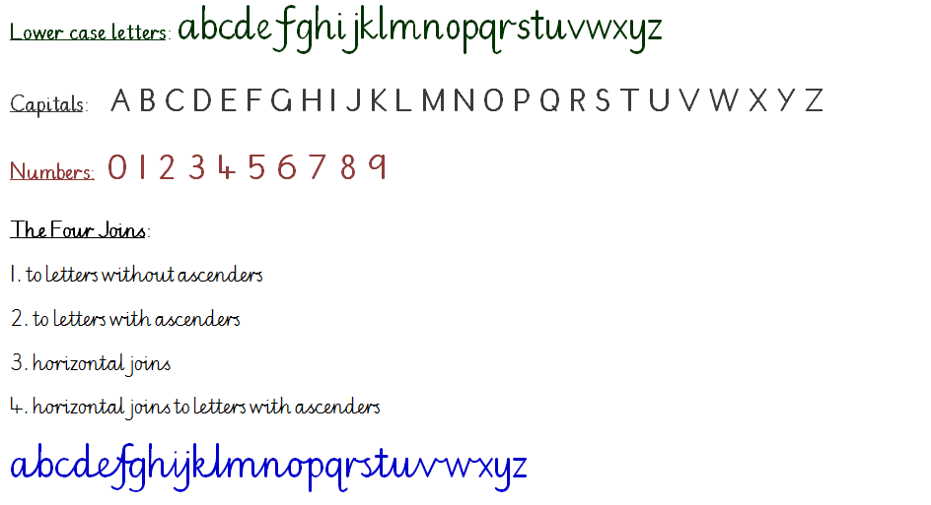 The break (letters that aren’t joined from) are: b g j p q x y z s

NB: children must be taught individual letters first so that they see them as individual units before learning to join.

In the **Foundation Stage**, handwriting will be implemented as follows:

* Children will develop hand eye coordination, gross and fine motor skills to support handwriting.
* Children will use a range of materials to develop drawing lines and circles using gross motorskills eg, painting.
* Children will use a range of materials to develop fine motor skills eg, wax crayons, markers, pencils, finger paints.
* Children will practice manipulative skills eg, playing with constructions, threading and playing instruments.
* Children will use a variety of tools and paper, indoors and outdoors, for purposeful writing eg, role play, labelling, making cards.
* Children will physically develop the movements of letter shapes using gross motor skills (linked to music and sounds) to gain confidence with the basic movements and flow of writing.
* Handwriting will be further embedded by teachers when they are carrying out the daily Phonics session.
* Children will be taught to form letters, using a variety of strategies and materials.
* Parents will be given the opportunity to support their child to practise their letter formation at home. Teachers will send home materials to enable parents to do this.

In **Year One**, handwriting should carry on as above. Correct pencil grip and posture should be modelled as part of everyday practice. Handwriting books should be used at an appropriate time. There should be 2 x 20 mins discrete sessions to develop handwriting. Each session will have a clear focus and the children will watch the teacher modelling letter formation and/or joins.

In **Year Two**, handwriting should be timetabled and where appropriate link with revision of phonics. All children should be allowed to use unlined paper from time to time, so that they can practise to apply skills and consider issues or presentation and aesthetics.

In **Key Stage 2**, all pupils will have access to discrete sessions to develop handwriting. For fluent writers, skills should be extended by encouraging children to evaluate their own and others’ writing. They should also attempt to write faster, retaining fluency and legibility- setting time challenges for each other. When children write neatly and legibly, with letters appropriately sized and spaced, they will obtain a ‘pen license’ and be able to write in black ink.

See **Appendix One** for the order of teaching.

**Assessment**

Children should be observed as they write during handwriting lessons- the teacher must circulate, monitor and intervene. Teachers also need to monitor and mark whole pieces of writing. The following should be considered:

* Is the posture correct?
* Does the child hold the pencil correctly?
* Does the child use the correct movement when forming and joining letters?
* Are any letters reversed or inverted?
* Does the child write fluently?
* Is the writing easily legible?
* Is the pupil’s handwriting development in line with age related expectations?

**Moderation of Writing**

As part of the school’s ongoing assessment of writing, children’s handwriting is taken into account when moderating examples of work and setting targets. If a child’s handwriting is not at the level of the content of their writing, then a handwriting intervention is put in place and handwriting practice may be sent as homework.

**Assessment at the End of Key Stage 2**

In order to be at the expected standard at the end of Key Stage 2, children must be able to maintain legibility, fluency and speed in handwriting through choosing whether or not to join specific letters.

**This policy has been produced by Mrs Hemingway in September 2017 and supersedes any previous policy.**

**Approved by governors on: 06/12/17**

**APPENDIX 1**

**Order of teaching**

**Single letters (YR and Y1)**

• c a d g q o

• e s f

• i l t

• u y j k

• r n m

• h b p

• v w x z

**Supporting activities**

• tracing patterns

• tracing

• copying over (letters, numbers and words)

• copying under (letters, numbers and words)

**Joins Y2 (going into Y3)**

Introduction of the four handwriting joins:

• First join; un um ig id ed eg an or ing ung

• Second join; ch sh th tl ll ill sli slu ck ack st sti ink unk

• Third join; od pg re ve oon oom

• Fourth join; wl vl of ff fl flo

• Practise the break letters b p g q y j z

• Practise capital letters

**Supporting activities**

• Match and copy captions

• Trace and copy patterns

• Copy words

• Copy sentences

• Write out menu

• Copy poem

• Alphabetical ordering

*See Nelson Handwriting Teacher’s Book p30 for learning outcomes and further information*

**Joins Y3 (going into Y4)**

Revision

• Practise the break letters b p g q y j z

• Practise capital letters

See *Nelson Handwriting Teacher’s Book* p30 *for learning outcomes and further information*

Further practise of the four handwriting joins:

• in ine

• ut ute

• ve vi

• ok oh

• sh as es (practising two ways of joining the letter s)

• ri ru ry (practising joining from the letter r)

• oa ad as (practising joining to and from the letter a)

• ee ea ed (practising joining from the letter)

• ow ov ox (practising joining from the letter o)

• ky hy ly (practising joining to the letter y)

• ha ta fa (practising joining to the letter a)

• od oo og( practising joining from the letter o)

• er ir ur (practising joining to the letter r)

• ai al ay

• o you oi

• re oe fe (practising the horizontal join to the letter e)

• fu wu vu (practising the horizontal join to the letter u)

• ot ol ok (practising joining to ascenders)

• ai al ow ol (practising all the joins)

**Supporting activities**

• copy words

• copy sentences

• copy poems

• match questions to answers

• copy jokes

• make and copy compound words

See *Nelson Handwriting Teacher’s Book* p54 *for learning outcomes and further information*

**Year 4**

• ning ping ting

• oc od oo

• ake ome are

• fla flo fle

• who wha whe

• ie in il

• inly ky ny

• ap ar an

• ick uck ack

• practise writing with a slope

• he

• we

• re

• fte fir fin

• wra wri kni (silent letters)

• ii ll tt rr nn mm cc oo dd ss ff ee

• ew ev ex (spacing)

• th ht fl (proportions)

• ac ag af

• Capital letters

• Decorated capital letters

• Practising with punctuation ! ? – “ “ , ‘

**Supporting activities**

• Copy words, sentences, poems

• Trace and copy

• Copy tongue twisters

• Copy instructions

See *Nelson Handwriting Teacher’s Book* p78 *for learning outcomes and further information*

**Example of break letters**



**Example of joins**

