Longroyde Primary School Child Protection Procedures

2018/19

Contents
Introduction
Section 1 – Pupil information
  - Pupil Information
  - Transfer of files

Section 2 – Role and Responsibilities

2.1 Governing Body

2.2 Head teacher

2.3 Designated Safeguarding lead

2.4 All Staff and Volunteers

Section 3 - Child Protection Procedures

  - Definitions

  - Concerns that staff must immediately report

  - Responding to disclosure

  - Action by the Designated Safeguarding lead

  - Action following a child protection referral

3.6 Recording and monitoring

Appendices
Appendix 1 Example Cause for Concern Form
Appendix 2 Body Map Guidance
Appendix 3 Referral flowchart

Introduction
These procedures should be read alongside the school’s Safeguarding Policy.

The aims of these procedures are:

- To clarify roles and responsibilities of everyone within our school in relation to safeguarding
- To have clear procedures that are followed when a child is identified as needing more than universal services can provide

The term “child “ or “children” refers to anyone under the age of 18 years

Section 1 – Pupil Information

1.1 In order to keep children safe and provide appropriate care for them the school requires accurate and up to date information regarding:

- names, contact details and relationship to the child of any persons with whom the child normally lives.
- names and contact details of all persons with parental responsibility (if different from above)
- emergency contact details (if different from above), ensuring that if the person(s) with parental responsibility is unable to collect this person, who could collect the child and keep them safe until either the person(s) with parental responsibility is available or a more suitable arrangement is made. The school encourages all parents and carers to provide more than one emergency contact, providing the school with additional options to make contact with a responsible adult when a child missing education is identified as a welfare and/or safeguarding concern
- details of any persons authorised to collect the child from school (if different from above)
- any relevant court orders in place including those which affect any person’s access to the child (e.g. Residence Order, Contact Order, Care Order, Injunctions etc.)
- if the child is or has been subject to a Child Protection Plan
- if the child is or has been subject to Early Intervention Single Assessment (EISA) or Child In Need (CIN) processes.
- If the child is a Child Looked After (CLA)
- name and contact detail of G.P.
- any other factors which may impact on the safety and welfare of the child

The school will collate, store and agree access to this information, ensuring all information held electronically is stored securely with due regard to meeting data protection and safeguarding requirements.

  - When a child leaves the school their child protection file is transferred to their new school as soon as possible and separately from the main pupil file. This is usually done with a face-to face meeting unless the child moves out of area, if this is the case the file is transferred by recorded delivery and signed for, and is clearly marked confidential. A receipt is obtained which states when the file was transferred and who delivered and received the file.

  - The school retains a copy of the child’s chronology and any documents that the school created eg. risk assessment in an archive until the child reaches the age of 25 years, or the age of 35 years if the child was subject to Child Protection procedures. The receipt of the transferred file is kept alongside this archive. Any archived files are stored securely in the same way as an active file.

Section 2 - Roles and Responsibilities

2.1 Our Governing Body will ensure that:

- there is a named Safeguarding Governor

- the school has an effective Safeguarding policy and Child Protection procedures in place that are in accordance with local authority guidance and locally agreed inter-agency procedures, and the policy is available publically via the school website or other means. The policy will be reviewed and updated on an annual basis

- the school has a staff behaviour policy or code of conduct and that this is provided to all staff and volunteers on induction. The policy includes acceptable use of technology, staff/pupil relationships and communications including the use of social media
- the school operates safer recruitment procedures and makes sure that all appropriate checks are carried out on staff and volunteers who work with children; and that any panel involved in the recruitment of staff has at least one member who has undertaken the Safer Recruitment Training.
- the school has procedures for dealing with allegations against staff and volunteers that comply with guidance from the local authority and locally agreed inter-agency procedures.
- online safety policy and procedures are in place and training and support is provided for staff and pupils to ensure that there is a good understanding of child protection issues related to electronic media.
- will ensure that the school has in place appropriate electronic filtering and monitoring systems in place to ensure that children are safeguarded from potentially harmful and inappropriate online material; whilst recognising that “over blocking” should not lead to unreasonable restrictions as to what children can be taught.
- a senior member of the school’s leadership team is appointed to the role of DSL who will take lead responsibility for safeguarding and child protection.
- the school has one or more deputy DSL’s who are trained to the same standard as the lead DSL.
- will ensure that children are taught about safeguarding, including online safety as part of providing a broad and balanced curriculum.
- staff including the Head teacher undertake appropriate safeguarding training which is updated annually
- they remedy, without delay, any deficiencies or weaknesses regarding child protection arrangements
- a governor is nominated to be responsible for liaising with the LA and /or partner agencies in the event of allegations of abuse being made against the head teacher
- where services or activities are provided on the school premises by another body, the body concerned has appropriate policies and procedures in place in regard to safeguarding children and child protection and liaises with the school on these matters where appropriate.
- they review their policies and procedures annually
- will ensure the appointment of an appropriately trained designated teacher with responsibility for “promoting the educational achievement of children who have left care through adoption, special guardianship or child arrangement orders or who were adopted from state care outside England and Wales” in addition to Children who are Looked After (CLA).

2.2 Our Head Teacher will ensure that:

- the policies and procedures adopted by the Governing Body or Proprietor are fully implemented, and followed by all staff;
- sufficient resources and time are allocated to enable the designated safeguarding lead and other staff to discharge their responsibilities including taking part in strategy discussions and other inter-agency meetings and contributing to the assessments of children.
- there are arrangements in place for Safeguarding Supervision for the Designated Safeguarding Lead and the deputy Designated Safeguarding Lead(s)
- all staff and volunteers feel able to raise concerns about poor or unsafe practice in regard to children, and such concerns are addressed sensitively and effectively in a timely manner in accordance with agreed whistle blowing policies
- the Designated Safeguarding Lead is supported in providing a contact for the school to provide a report and attend Initial Child Protection Case Conferences, Reviews and Children Looked After Reviews out of school term time when needed

- allegations regarding staff or any other adults in the school are referred to the Local Authority Designated Officer (LADO), as set out in the Managing Allegations procedure.
- individuals are referred to the Disclosure and Barring Service (cases where a person is dismissed or left due to risk/harm to a child). This is a legal duty placed upon the school.

2.3 Our Designated Safeguarding Lead (DSL) as stated in KCSIE (2018) will ensure that they:

Manage referrals
• Refer cases of suspected abuse to the local authority children’s social care (MAST);
• Support staff who make referrals to MAST;
• Refer cases to the Channel programme where there is a radicalisation concern;
• Support staff who make referrals to the Channel programme;
•Support the Head to refer cases where a person is dismissed or left due to risk/harm to a child to the Disclosure and Barring Service as required; and
• Refer cases where a crime may have been committed to the Police.

Work with others
• Liaise with the headteacher to inform them of issues especially ongoing enquiries under section 47 of the Children Act 1989 and police investigations;
• As required, liaise with the “case manager” (as per Part four of KCSIE) and the designated officer (LADO) for child protection concerns (all cases which concern a staff member or volunteer); and
• Liaise with staff on matters of safety and safeguarding and when deciding whether to make a referral by liaising with relevant agencies. Act as a source of support, advice and expertise for staff.

Undertake training

The DSL (and any deputies) will undergo training to provide them with the knowledge and skills required to carry out the role. This training will be updated at least every two years. They will also undertake Prevent awareness training.

In addition to the formal training, their knowledge and skills will be refreshed at regular intervals, as required, but at least annually, to allow them to understand and keep up with any developments relevant to their role (this will be done by attending the termly DSL Network Meetings and by attending appropriate Calderdale Safeguarding Children Board multi-agency training and other relevant training and/or conference opportunities) so they:
• Understand the assessment process for providing early help and intervention, for example through locally agreed common and shared assessment processes such as early help assessments;
• Have a working knowledge of how local authorities conduct a child protection case conference and a child protection review conference and be able to attend and contribute to these effectively when required to do so;
• Ensure each member of staff, especially new and part time staff has access to and understands the school’s or college’s child protection policy and procedures;
• Are alert to the specific needs of children in need, those with special educational needs and young carers;
• Are able to keep detailed, accurate, secure written records of concerns and referrals;
• Understand and support the school or college with regards to the requirements of the Prevent duty and are able to provide advice and support to staff on protecting children from the risk of radicalisation;

• Obtain access to resources and attend any relevant or refresher training courses; and
• Encourage a culture of listening to children and taking account of their wishes and feelings, among all staff, in any measures the school or college may put in place to protect them.

Raise Awareness
• The DSL will ensure that the school or college’s child protection policies are known, understood and used appropriately;
• Ensure the school or college’s child protection policy is reviewed annually the procedures and implementation are updated and reviewed regularly, and work with governing bodies or proprietors regarding this;
• Ensure the child protection policy is available publicly and parents are aware of the fact that referrals about suspected abuse or neglect may be made and the role of the school or college in this; and
• Link with the local LSCB to make sure staff are aware of training opportunities and the latest local policies on safeguarding.

Availability
• During term time the designated safeguarding lead (or a deputy) will always be available for staff in the school or college to discuss any safeguarding concerns.
• There will also be a DSL or deputy available to be contacted out of hours/out of term for urgent enquiries such as an Initial Child Protection Case Conference.

The DSL in charge is Mr R Fox.
He is supported by assistant DSLs who are;
Mrs S Lyall (FTR) and Mrs C Buchanan (FTR)
Mrs B R-Flinn (LR) and Miss C Shields (Both sites)

2.4 All staff and volunteers will:

- read and sign to say that they understand and will fully comply with the
school’s policies and procedures
- read and sign to say that they understand Part 1 of ‘Keeping Children Safe in
Education’ (2018)
- attend annual whole school training and other appropriate training identified
- identify concerns as early as possible and provide help, to prevent concerns from escalating and identify children who may be in need of extra help or who are suffering or are likely to suffer significant harm
- provide a safe environment in which children can learn
- be aware that they may be asked to support a Social Worker to take decisions about individual children
- inform the designated safeguarding lead of any concerns about a child immediately
- inform the head of any concerns regarding an adult within school at the earliest opportunity
- inform the Chair of Governors of any concerns regarding the head at the earliest opportunity

Section 3 – Child Protection Procedures

3.1 Teachers and other adults in school are well placed to observe any physical, emotional or behavioural signs which indicate that a child may be suffering significant harm. The relationships between staff, pupils, parents and the public which foster respect, confidence and trust can lead to disclosures of abuse, and/or school staff being alerted to concerns. Definitions of the four main types of abuse are within the Safeguarding Policy.

All staff will also have an awareness of specific safeguarding issues as referred to in the Safeguarding Policy, in particular Domestic Abuse, Child Sexual Exploitation (CSE), Radicalisation and the Prevent Duty, Female Genital Mutilation (FGM), Attendance and Children Missing from Education (CME). Staff will also be aware that behaviours linked to drug taking, alcohol abuse, truanting and sexting put children in danger.

All staff will also be aware that safeguarding issues can manifest themselves via peer on peer abuse. This is most likely to include, but not limited to: bullying (including cyber bullying), gender based violence/sexual assaults and sexting. Staff are clear as to the school or college’s policy and procedures with regards to peer on peer abuse.

3.2 It is not the responsibility of the school staff to investigate welfare concerns or determine the truth of any disclosure or allegation. All members of staff however, have a duty to recognise concerns and maintain an open mind. Accordingly all concerns regarding the welfare of pupils will be recorded and discussed with the designated safeguarding lead (or the deputy DSL in the absence of the DSL) prior to any discussion with parents.

If children are placed in any form of Alternative Provision for any part of their school day, this school will seek reassurance that the same child protection procedures will be followed and that any concerns will likewise be reported to our Designated Safeguarding Lead and their counterpart within the Alternative Provision.

Concerns that staff must immediately report:

- any suspicion that a child is injured, marked, or bruised in a way which is not readily attributable to the normal knocks or scrapes received in play
- any explanation given which appears inconsistent or suspicious
- any behaviours which give rise to suspicions that a child may have suffered harm (e.g. worrying drawings or play)
- any concerns that a child may be suffering from inadequate care, ill treatment, or emotional maltreatment
- any concerns that a child is presenting signs or symptoms of abuse or neglect
- any significant changes in a child’s presentation, including non-attendance
- any hint or disclosure of abuse from any person
- any concerns regarding person(s) who may pose a risk to children (e.g. living in a household with children present)
- any potential indicators of CSE
- any potential indicators of FGM
- any potential indicators of Radicalisation
- any potential indicators of living in a household with Domestic Abuse

3.3 Responding to Disclosure

Disclosures or information may be received from pupils, parents or other members of the public. School recognises that those who disclose such information may do so with difficulty, having chosen carefully to whom they will speak. Accordingly all staff will handle disclosures with sensitivity.

Such information cannot remain confidential and staff will immediately communicate what they have been told to the designated safeguarding lead and make a contemporaneous record.

Principles:

Staff will not investigate but will, wherever possible, elicit enough information to pass on to the designated safeguarding lead in order that s/he can make an informed decision of what to do next.

The Designated Safeguarding Lead will ensure that the child’s wishes and feelings are taken into account when determining what action to take and what services to provide. Child Protection processes will operate with the best interests of the child at their core.

Staff will:
- listen to and take seriously any disclosure or information that a child may be at risk of harm
- try to ensure that the person disclosing does not have to speak to another member of school staff
- clarify the information
- try to keep questions to a minimum and of an ‘open’ nature e.g. using TED technique – ‘Tell me, Explain to me, Describe to me….’
- try not to show signs of shock, horror or surprise
- not express feelings or judgements regarding any person alleged to have harmed the child
- explain sensitively to the person that they have a responsibility to refer the information to the designated safeguarding lead, children need to know that staff may not be able to uphold confidentiality where they are concerns about their safety or someone else’s
- reassure and support the person as far as possible
- explain that only those who ‘need to know’ will be told
- explain what will happen next and who will be involved as appropriate
- record details including what the child has said, in the child’s words on a ‘Record of Concern’/’Cause for Concern’ form (Example in Appendix 1) or on electronic system eg. CPOMS and record any visible signs, injuries or bruises on a Body Map (Example in Appendix 2).
- record the context and content of their involvement, and will distinguish between fact, opinion and hearsay

3.4 Action by the Designated Safeguarding Lead (or deputy DSL in their absence)

Following any information raising concern, the designated safeguarding lead will consider:

- any urgent medical needs of the child
- whether the child is subject to a child protection plan
- discussing the matter with other agencies involved with the family
- consulting with appropriate persons e.g. Early Intervention Service Manager, Multi-Agency Screening Team (MAST) and/or Safeguarding Advisor for Education
- the child‘s wishes

Then decide:

- to talk to parents, unless to do so may place a child at risk of significant harm, impede any police investigation and/or place the member of staff or others at risk
- whether to make a child protection referral to Multi-Agency Screening Team (MAST) because a child is suffering or is likely to suffer significant harm and if this needs to be undertaken immediately
OR
- not to make a referral at this stage
- if further monitoring is necessary
- if it would be appropriate to undertake an assessment (e.g. Early Intervention Single Assessment - EISA) and/or make a referral to the Early Intervention Panel and/or to other services.

All information and actions taken, including the reasons for any decisions made, will be fully documented and the process depicted in the flowchart in Appendix 3 will be followed. All referrals to Multi-Agency Screening Team (MAST) will be followed up in writing using the Calderdale Request for Service/Referral Form and these referrals will always be kept on file irrespective of the outcome.

If the DSL is of the view that concerns are not being responded to appropriately then these concerns will be escalated appropriately until the DSL feels that some resolution has been achieved. Initial escalation would be to the Team Manager, but need progressing to the Service Manager if felt appropriate.

3.5 Action following a child protection referral

The designated safeguarding lead or other appropriate member of staff will:

- make regular contact with the social worker involved to stay informed
- wherever possible, contribute to the strategy discussion
- provide a report for, attend and contribute to any subsequent child protection conference
- if the child or children are made the subject of a child protection plan, contribute to the child protection plan and attend core group meetings and review conferences
- where possible, share all reports with parents prior to meetings
- where in disagreement with a decision made by Multi-Agency Screening Team (MAST) e.g. not to apply child protection procedures or not to convene a child protection conference, follow the guidance in the West Yorkshire Consortium Safeguarding Children Procedures - 8.2 Resolving Professional Disagreements.
Calderdale MAST management team operate an escalation policy which can be triggered in the event of any professional disagreement as to a course of proposed action.
- where a child subject to a child protection plan moves from the school or goes missing, immediately inform Multi-Agency Screening Team (MAST)

3.6 Recording and monitoring

Accurate records will be made as soon as practicable and will clearly distinguish between observation, fact, opinion and hypothesis. All records will state who is providing the information, the date and time, information will be recorded in the child’s words where possible and a note made of the location and description of any injuries seen, if this is a paper record than this should be signed. An example of how this is done can be found in Appendix 1.

The DSL ensures that the method for other members of staff of volunteers passing on concerns or information is always adhered to as consistency is paramount in ensuring that nothing gets missed. All actions will also show what action is being taken as a result of the concern and the outcomes of this action.

All documents will be retained in a ‘Child Protection file’, separate from the child’s school file. This will be locked away and only accessible to the head teacher and the DSL if a paper file. If an electronic file eg. using CPOMS (Child Protection Online Management System), it will be stored securely with appropropriate levels of limited access. These records will be transferred to any school or setting the child moves to, clearly marked ‘Child Protection, Confidential, for attention of Designated Safeguarding Lead for Child Protection,’ and a receipt of this transfer will be retained. The chronology from the file and any key documents generated by the school will then be retained by the school until the child’s 25th birthday or for 40 years from the date of birth of the youngest sibling within a family if they are or have been subject to Child Protection procedures.

If the child goes missing from education or is removed from roll to be educated at home, any child protection file will be transferred and sent to the Education Welfare Service.

Appendix 1

Child Protection
Cause for Concern Form

Date: |  | Time:
Name of Child:
Date of Birth: |  | UPN Number:
Reporting Adult: |  | Role:
Reporting Adult Signature: |  | DSL Signature:

Details of Concern (who, what, where, when):

Facts -

Opinions -

DSL Follow up:

Early Intervention Service Manager Contacted for advice Yes/No

Early Intervention Panel Referral Yes/No

MAST Contacted for advice: Yes/No

MAST Referral: Yes/No

Time of contact:

Outcome of contact:

Child’s CASS Number:

Actions:

Review Date:

Appendix 2

Body Map Guidance for Schools

Body Maps should be used to document and illustrate visible signs of harm and physical injuries.

Always use a black pen (never a pencil) and do not use correction fluid or any other eraser.

Do not remove clothing for the purpose of the examination unless the injury site is freely available because of treatment.

*At no time should an individual teacher/member of staff or school take photographic evidence of any injuries or marks to a child’s person, the body map below should be used. Any concerns should be reported and recorded without delay to the appropriate safeguarding services, e.g. MAST or the child’s social worker if already an open case to social care.

When you notice an injury to a child, try to record the following information in respect of each mark identified e.g. red areas, swelling, bruising, cuts, lacerations and wounds, scalds and burns:

- Exact site of injury on the body, e.g. upper outer arm/left cheek.
- Size of injury - in appropriate centimetres or inches.
- Approximate shape of injury, e.g. round/square or straight line.
- Colour of injury - if more than one colour, say so.
- Is the skin broken?
- Is there any swelling at the site of the injury, or elsewhere?
- Is there a scab/any blistering/any bleeding?
- Is the injury clean or is there grit/fluff etc.?
- Is mobility restricted as a result of the injury?
- Does the site of the injury feel hot?
- Does the child feel hot?
- Does the child feel pain?
- Has the child’s body shape changed/are they holding themselves differently?

Importantly the date and time of the recording must be stated as well as the name and designation of the person making the record. Add any further comments as required.

Ensure First Aid is provided where required and then recorded appropriately.

A copy of the body map should be kept on the child’s concern/confidential file.

BODYMAP
(This must be completed at time of observation)

Name of Pupil: |  |  | Date of Birth:
Name of Staff: |  |  | Job title:
Date and time of observation:

Name of pupil: |  |  | Date and time of observation:
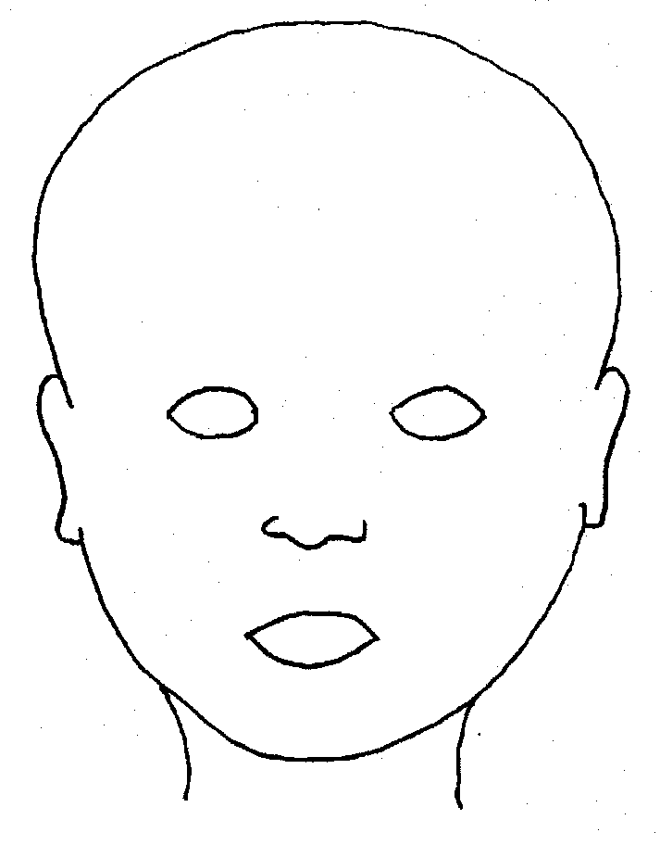
FRONT |  | BACK
 |  | 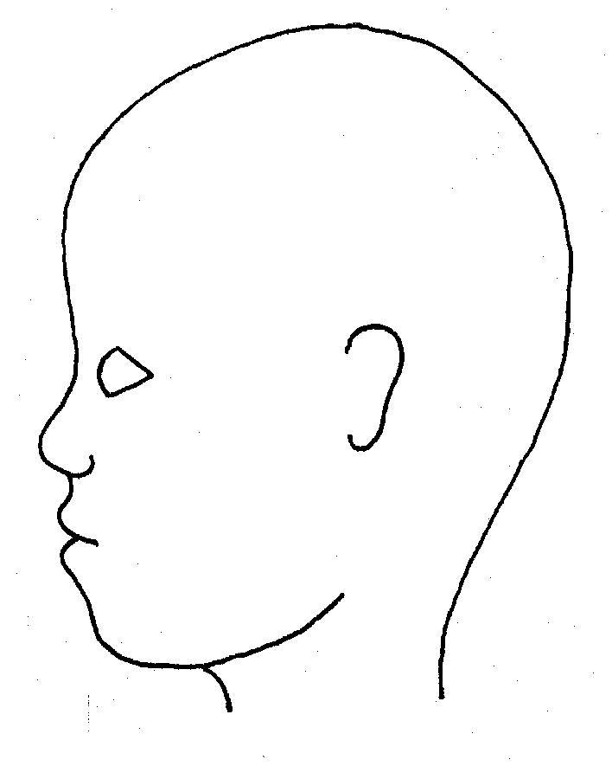
RIGHT |  | LEFT

Name of pupil: |  |  |  |  |  |  | Date and time of observation:
 |  |  |  |  |  | 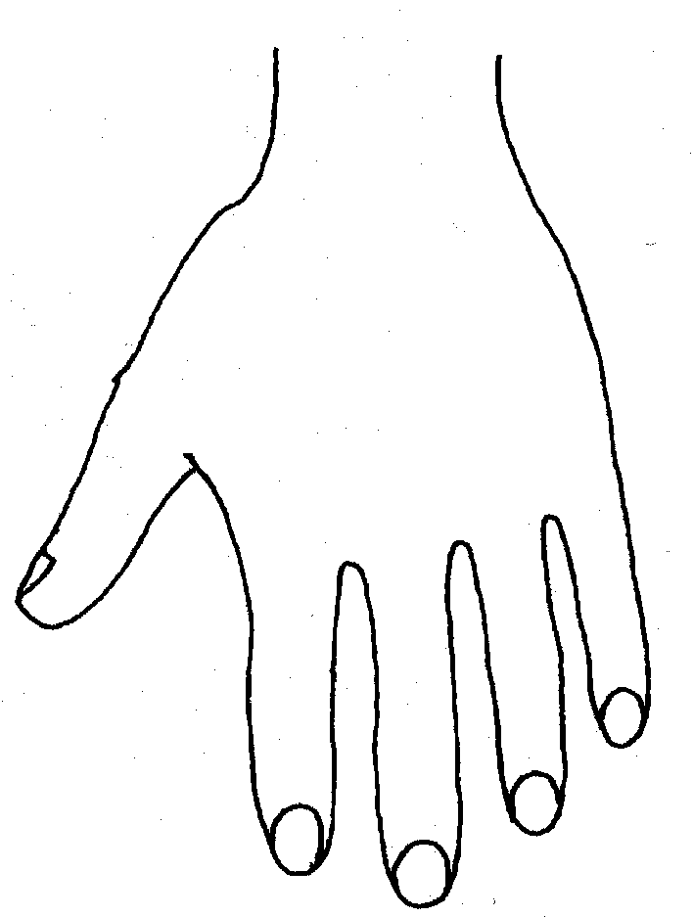
R |  |  |  |  |  | L
BACK
FRONT
Name of Pupil: |  |  |  |  |  |  | Date and time of observation:
R |  | TOP | L |  | R |  |  | BOTTOM |  | L
R |  |  |  |  | L
INNER
R |  |  |  |  | L
OUTER
Name:

Signature:
Job title of staff:

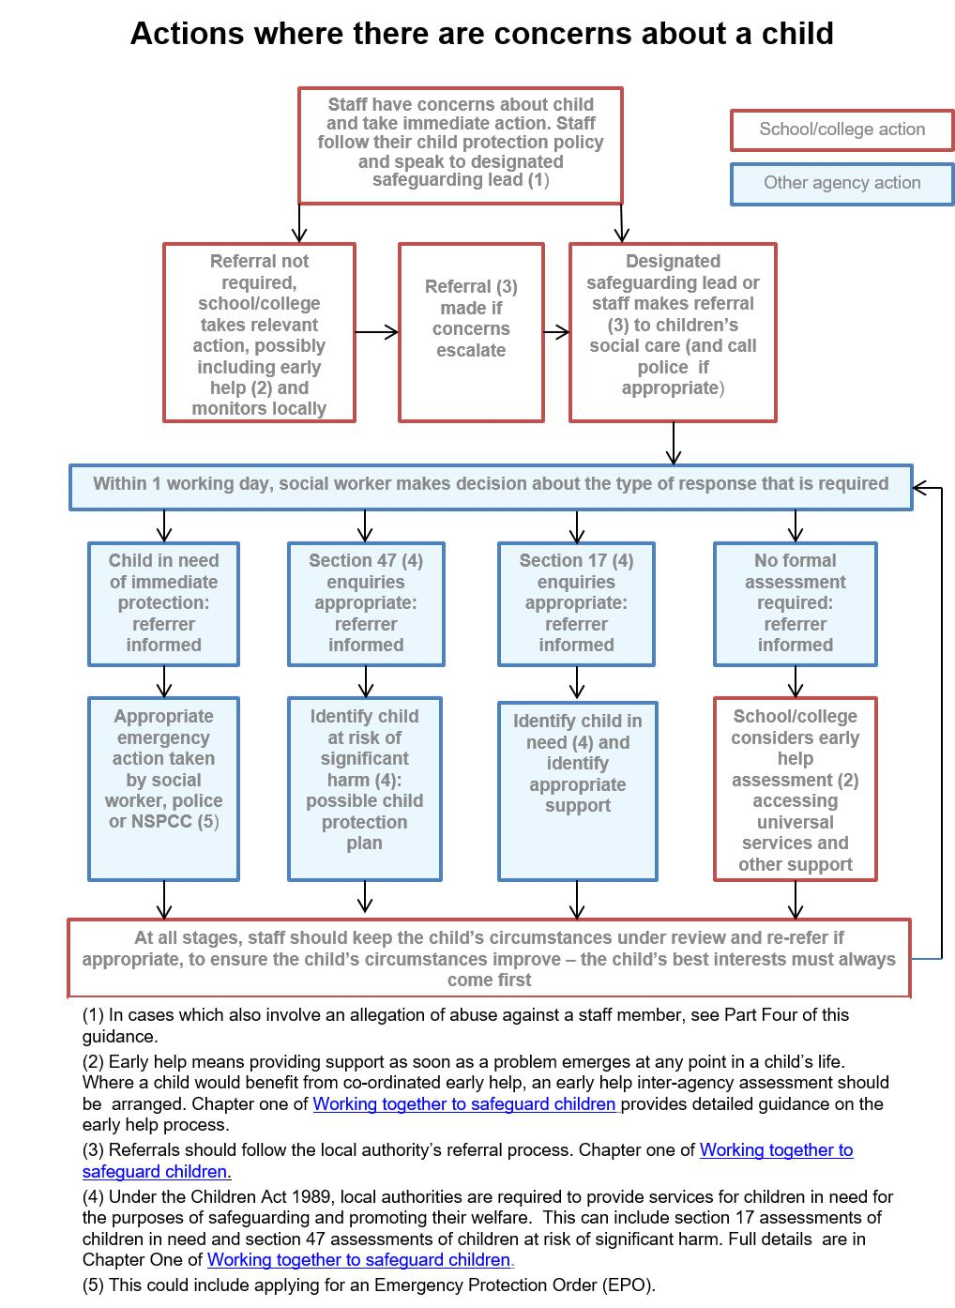Appendix 3 – Flowchart from KCSIE 2018

