Price List

Morning Sessions

7.30 am | 9.00 am | £5.50
8.00 am | 9.00 am | £5.00
8.30 am | 9.00 am | £3.50
Afternoon Sessions

3.00 pm | 4.00 pm | £4.00
3.00 pm | 6.00 pm | £8.50

All costs include drop off and collection from Longroyde Road Site, if required. Payment is required in advance.

Breakfast is provided during the morning session and a snack during the afternoon session.

Children from the age of 3 years to 11 years are welcome.

Children from the age of 7 to 11 years also have the choice of Hooters OOSC facility at the Longroyde Road Site.

We provide various activities on a daily basis including crafts, baking, role play, DVD’s, reading and outdoor play.

Policies are available on request.

Bills are issued on a monthly basis or you can arrange payments at the school office.

Monday |  | Tuesday |  | Wednesday |  | Thursday |  | Friday
AM | PM | AM | PM | AM | PM | AM | PM | AM | PM
Child’s Name |  |  |  |  |  | Class

Please indicate which sessions you require and the Out of School Manager will contact you to confirm availability.

Please note ALL booked days will be charged unless the OOSC closes the facility. Invoices must be paid within 7 days of receipt.

The Fun House Mission Statement

The Fun House Out of School Club aims to provide high quality childcare at a reasonable cost within a relaxed, safe and stimulating environment.

We promote an ethos of friendship and creativity, with the children being our focus at all times.

The children and staff value one another and work together to create a happy club where each child can play, have fun and make friends.

The Fun House staff are committed to meeting the needs of parents and carers by listening to any views or concerns they may have.

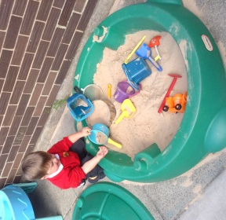

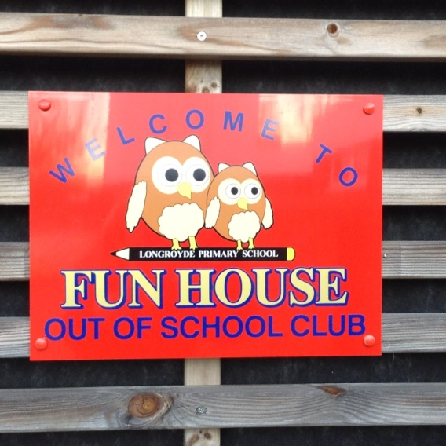
OPENING TIMES
Morning Session
7.30 am to 9.00 am

Afternoon Session
3.00 pm to 6.00 pm

TELEPHONE
07547511032
7.30 am to 9.00 am
3.00 pm to 6.00 pm
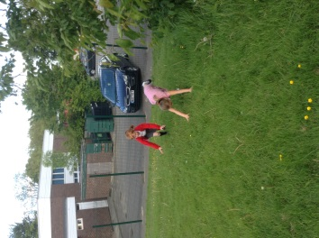
01484 715300
9.00 am to 3.00 pm

If you have any queries please contact:
Mrs Rhodes or Mrs Thompson
(Out of School Managers)

